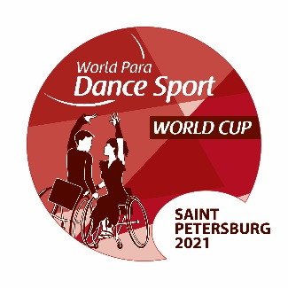 | Saint Petersburg 2021 World Para Dance Sport  WORLD CUP  10 - 12 September 2021  ENTRY FORM | 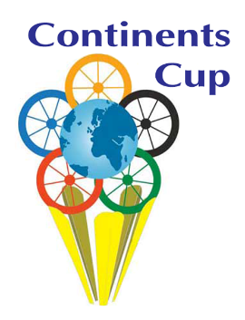

Couple | Partner / Man |  | Partner / Lady
Surname / Name
Date of birth dd/mm/year
EVENTS
Combi ST
Combi LA
Combi Freestyle
Duo ST
Duo LA
Duo Freestyle
Single Conventional
Single Freestyle
Single Junior
Class 1-2
(please, indicate)
Wheelchair user
(please, indicate who)
SDMS License
2021 season: (YES/NO)
NPC:
Address:
Contact person:
Telephone: |  | E-mail:
Amateur Declaration Statement according to the clause 3.3 of the 2018 WPDS Rules and Regulations:
“I confirm that I am not: a National Coach, Team Leader or Adjudicator. I also confirm that I am not a Professional Standing Dancer and that if I once was I am now retired and have not competed as a Professional Standing Dancer for at least one (1) consecutive year”
Athletes’ signature:
Date:
Signature and stamp: ( )
National Paralympic Committee or relevant organization, endorsed by NPC.
The Entry Form should be sent by e-mail no later than 02 August 2021 to the LOC and WPDS.

