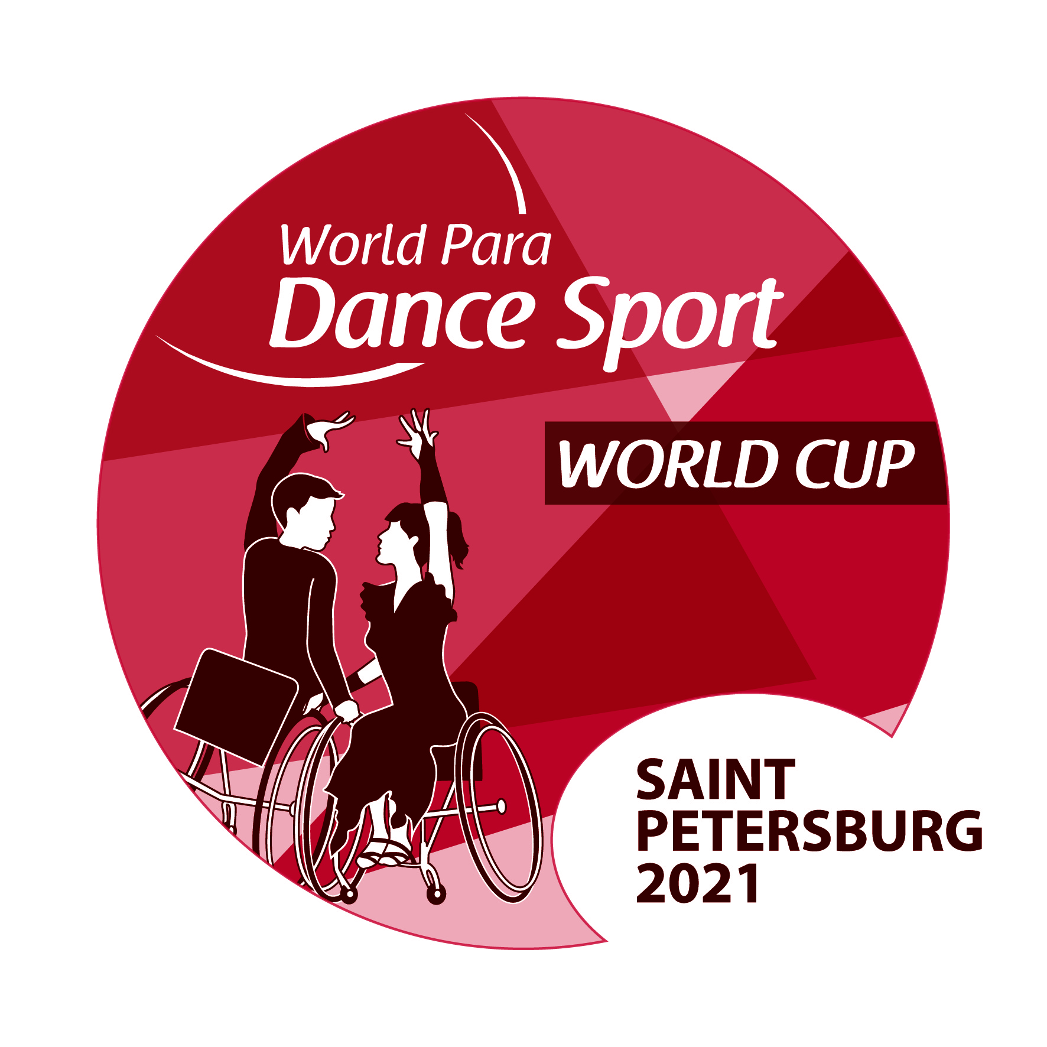 |  |  | SAINT PETERSBURG 2021  WORLD PARA DANCE SPORT  WORLD CUP  Saint Petersburg, Russia  8–13 September, 2021  ADDITIONAL FORM
№ | Room  № | Surname / Name |  | Who is who? (dancer, trainer, attendant, etc.)  Please mark wheelchair users
1 | 1
2
3 | 2
4
5 | 3
6
7 | 4
8
9 | 5
10
11 | 6
12
13 | 7
14
15 | 8
16
17 | 9
18
19 | 10
20
21 | 11
22

Please fill the form in accordance with who will live with whom in one room.

Flight Schedule

Arrival
From | To (indicate airport) | Flight No | Date | Time | Number of persons / only in wheelchair | Number of  wheelchairs
 |  |  |  |  | /
From | To (indicate airport) | Flight No | Date | Time
From | To (indicate airport) | Flight No | Date | Time
Departure
From | To (indicate airport) | Flight No | Date | Time | Number of persons / only in wheelchair | Number of  wheelchairs
 |  |  |  |  | /
From | To (indicate airport) | Flight No | Date | Time
From | To (indicate airport) | Flight No | Date | Time

The Form should be sent by e-mail no later than 2 August, 2021

Important: In case the group is split and takes different flights, please, inform the LOC correspondingly by sending another additional form fulfilled.

Date:
Signature and stamp: ( )

